EXCHANGE OF VARIABLES

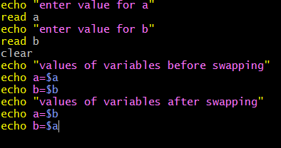

OUTPUT

